The One With The Baby Shower

Written by: Sherry Bilsing-Graham & Ellen Plummer
Transcribed by: Eric Aasen
820 新生儿派对
莫妮卡和菲比准备给瑞秋开个新生儿派对，却忘了邀请瑞秋的母亲Mrs. Green。
乔伊得到个主持游戏节目的试镜机会，但游戏太复杂。罗斯和钱德扮作参赛者帮他熟悉游戏程序。
派对开始，Mrs. Green对自己没被邀请耿耿于怀，莫妮卡竭尽全力拍她马屁，请求她的原谅。
瑞秋对抚养孩子一无所知，Mrs. Green提出住在他们家帮她带8周的孩子。
罗斯得知后赶快说他们应付得来，没有这个必要。
乔伊去试镜时被告知游戏太复杂，观众很难明白，改成简单的问答。
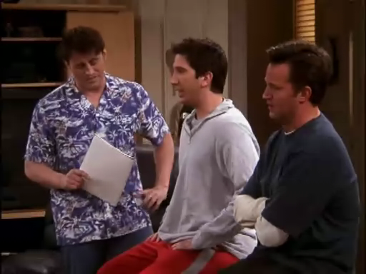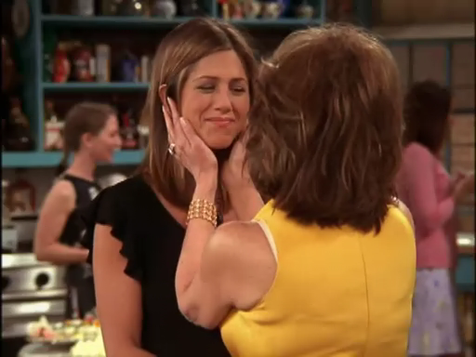
8.20 The One With The Baby Shower
Joey, preparing to audition for a new game show, gets help rehearsing from Ross and Chandler.
The complex rules are confusing at first, but after a while the guys really take a liking to it.
Monica and Phoebe throw Rachel a baby shower, but forget to invite her mother until the last minute.
Mrs. Green offers to live with Rachel and Ross for a couple months, to help with the baby.
Rachel becomes convinced that it is necessary, but Ross doesn't share her feelings.
When Joey finally goes for his audition, he learns that the game show has been simplified to a basic question and answer format. [Scene: Monica and Chandler's, Monica and Phoebe are preparing for Rachel’s baby shower.]
Rachel: (entering) Hi!
Monica: Hey!
Phoebe: Hey!
Rachel: So what’s the final head count on my baby shower?
head count n.点人数 总人数[eg: The monitor did a head count]
Phoebe: About twenty, a couple people from work who had something else to do.
Monica: Also both of your sisters called and neither can make it.
Rachel: What?! You mean they’re not coming to a social event where there’s no men and there’s no booze?! That’s shocking! I don’t care, as long as my mom’s here.
Social event n.社交活动/booze n.酒
Monica: Oh my God, your mother!
Rachel: What?! My mom’s not gonna be here?!
Monica: Well, given that we forgot to invite her it would be an awfully big coincidence if she was.
given prep.假如 考虑到(+that)[eg: Given the same treatment again, he is sure to get well]
Rachel: My God!
Monica: Well it wasn’t my fault, Phoebe was in charge of the invitations!
Phoebe: Well I don’t, I don’t have a mother so often I forget that other people…
Monica: (interrupting her) Oh give it a rest!
give it a rest<美口>停止抱怨或是停止做某件事 得了吧
Rachel: So my mother is not coming to my baby shower?!
Phoebe: No. (Pause) Neither is mine.
Monica: Okay, y’know what? Don’t worry, okay? We’ll take care of it. We’ll call her. Just go home and get ready.
Rachel: Please, make sure she comes. It’s really important to me, I mean it’s my mom!
Phoebe: I know. I know, what’s her number?
Rachel: I don’t know.
Monica: Go! I have it in my book. Go! (Rachel leaves and Monica calls Mrs. Green.) (To Phoebe) Wait a minute! If you’re in charge of the invitations why am I the one who has to call her—Hello Mrs. Green! Hi, it’s Monica Geller.
Mrs. Green: Oh, hello Monica.
Monica: (on phone) Hi, umm I know this is last minute, but we’ve decided to throw an impromptu baby shower for Rachel today.(Phoebe gives her thumb up)
last minute n.最后关头/impromptu adj.事先无准备的 即兴的[eg:The President gave an impromptu press conference]
Mrs. Green: I know, my daughters told me about it when they received their impromptu invitations a month ago.
Monica: Yeah, I’m sorry. I’m-I’m so sorry.
Mrs. Green: For what dear? For not inviting me or lying about it?
lie about v.就…撒谎
Monica: (To Phoebe) Oh my God, my ass is sweating! (on phone) I'm sorry for everything. Really, I mean, there's a lot of planning in a baby shower.You know, things get overlooked and Phoebe's mother killed herself.(Phoebe nods yes)
planning n. 制订计划/overlook vt.看漏 忽略[eg: My calculation was wrong because I overlooked one tiny point]
Mrs. Green: Why? Did you forget to invite her too?
Monica: (fakes laugh )Oh, you're so funny. Please, please, can you come? It starts at 4:00.
Mrs. Green: Well,all right I’ll see you at four.
Monica: Thank you. (Hangs up.)
Phoebe: Isn’t it at three?
Monica: Son of a bitch! (Calls Mrs. Green again.)
Opening Credits
[Scene: Joey's Apartment, Joey is reading a script as Ross and Chandler enter carrying a basketball.]
Chandler: Hey Joe! You wanna shoot some hoops?(To ross) And for the record, I am not covering the tall one this time.
hoop n. (篮球的)篮 [eg:shoot hoops投篮]/for the record adv.郑重声明[eg: Just for the record, I think the President is a fool]/cover<口>防守

Ross: Fine, but she's not that tall.
Joey: Oh no, I can’t go. I’m practicing，I got an audition to be the host of a new game show.
Ross: Oh cool!
Chandler: That’s great.
Joey: Yeah-yeah, and if I get it by day I’ll be (In a sexy voice) Dr. Drake Remoray, but by night I’ll be (In an announcer’s voice) Joey Trrrribbiani!
by day adv.在白天/by night adv.在夜里
Chandler: You’ll be perfect for this! That’s already your name!
Joey: I know. I know. It'd be so great if I got this because you never know what could happen on a soap. But I could be a game-show host forever. Like that Bob Barker guy. He's been doing The Price is Right for 75 years.
Robert William "Bob" Barker (born December 12, 1923) is a seventeen-time Emmy Award-winning American television game show host. He is best known for hosting CBS's The Price Is Right since September 4, 1972, making it the longest-running daytime game show in television history. On October 31, 2006 he announced that he would retire from hosting The Price Is Right in June 2007 after holding the job for thirty-five years and having been in television for fifty years.
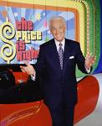
The Price Is Right is a popular American game show based on contestants guessing the retail prices(n.零售价) of featured prizes and other promotional products. The modern United States version premiered on September 4, 1972 on CBS and is hosted by Bob Barker, although Barker announced on October 31, 2006, that he would retire at the end of this season; the show will continue with a new host, who has yet to be determined. Off-air auditions for the future host will begin on December 8.The show began its 35th season on September 18, 2006.It is based on the original US version of the show, which aired on NBC and later ABC from 1956 to 1965 and was hosted by Bill Cullen.TV Guide named The Price Is Right the "greatest game show of all time."It is only one of two game-show franchises to be seen nationally in either first-run network or syndication airings in every decade from the 1950s onward(adv.在前面); the other is To Tell the Truth. Price is reflected in pop culture by phrases such as "Come on down!" and "This showcase (or prize) can be yours if the price is right!"
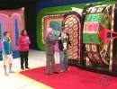
Chandler: I bet the ratings weren't good for the first 25. You know, before there was television.
rating n.收视率
Joey: But the problem, this game is really complicated.
Ross: Come on. You said the same thing about Hungry Hungry Hippos.And last week, you beat Ben.
hippo n.河马/Hungry Hungry Hippos is a board game made for young children by Hasbro of Pawtucket, Rhode Island, under the brand of its subsidiary(n.子公司), Milton Bradley
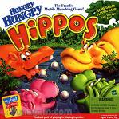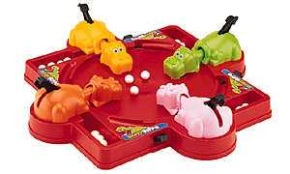
Joey: Yeah. I have to be honest with you guys.He kind of let me win.But the audition’s in a couple hours and I don’t even understand the game.
Ross: Well do you want some help?
Joey: Oh really? That’d be great! You guys can be the contestants!
Ross: Awesome!
Chandler: Okay, I guess we can lose to junior high girls some other time.
lose vi. 输掉 失败(+to)[eg: Cambridge lost to Oxford]/some other time adv.改天吧[eg:Maybe some other time]
Joey: (announcer voice) All right! Let’s play Bamboozled!
bamboozle vt.欺骗 哄骗
Chandler: Bamboozled?
Joey: Yeah, isn’t that a cool name?
Ross: (simultaneously with Chandler) Yeah!
Chandler: (simultaneously with Ross) No!
Joey: All right. Uhh, okay. Our first contestant is Ross Geller. Why don’t you tell us a little bit about youself Ross?
Ross: Well uh, I-I’m a paleontologist. Umm, I-I live in New York. I have a son Ben. Uh, hi Ben! (Waves.) And uh…
Joey: I said a little bit Ross. Now, how about you Chandler?
Chandler: Well Joey, I’m a headhunter. I hook up out-of-work Soviet scientists with rogue third-world nations. Hi Rasputin! (Waves.)
headhunter n.猎头[eg: Nowadays a good headhunter is as important as good staff]/hook up v. To meet or associate[eg:We agreed to hook up after class]/hook up sb with sth 把某人引荐给Sth/out-of-work adj.失业的/rogue n.流氓 无赖[eg: Don't buy a used car from that rogue]/rogue third-world nations n.流氓第三世界国家/Grigori Yefimovich Rasputin (or Grigori Yefimovich Novyh) (January 22 1869 O.S. January 10]–December 29 1916 O.S. December 16]) was a Russian mystic(n.神秘家) who held an influence in the later days of Russia's Romanov dynasty. Rasputin played an important role in the lives of Tsar Nicholas II, his wife the Tsaritsa Alexandra, and their only son the Tsarevich Alexei, who suffered from haemophilia(n.血友病).

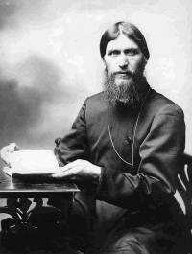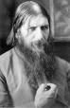
Joey: Excellent! Let’s play Bamboozled! Chandler, you’ll go first. What is the capital of Columbia?
Chandler: Bogota.
Bogota n.波哥大(哥伦比亚首都)
Joey: It’s Ba-go-ta, but close enough. Now, you can either pass your turn to Ross or pick a Wicked Wango card.
wicked adj.邪恶的
Chandler: What does a Wicked Wango card do?
Joey: I should know that. Let’s see, just one moment please. Umm, here we are, a Wicked Wango card determines whether you go higher or lower.
Chandler: Higher or lower than what?
Joey: This is embarrassing. (Looks it up.)
Chandler: (To Ross) Can you believe how lame this is?
Ross: I’m sorry, I don’t believe contestants are allowed to talk to each other.
believe v.认为
[Scene: Monica and Chandler's, Rachel’s baby shower is underway. Monica and Phoebe are working in the kitchen.]
be underway adv.在进行中
Phoebe: Oh, I told the stripper to be here at five. That’s good,right?
Monica: You ordered a stripper for the shower?! That is totally inappropriate!
Phoebe: What? He’s gonna be dressed as a baby! (Mrs. Green enters.) Oh hi Mrs. Green!
Monica: Hi!
Phoebe: I’m so glad you could make it.
Monica: Yes, thank you so much. And again, we’re so sorry. We could not feel worse about it.
Mrs. Green: Try. There’s my little girl. (Goes over to Rachel.)
Monica: She’s still mad.
Phoebe: Yeah I know. Isn’t it great? One less person we have to make small talk with.
make small talk with sb 和某人闲聊
One Strange Woman：Hey, how are you?
Phoebe: Yeah, yeah. Okay, okay.
Monica: Phoebe, Sandra’s mad at you too. It-it doesn’t bother you?
Phoebe: No look, we’ve apologized twice! I can’t do anymore than that. I know you hate it when people are mad at you but you just have to be okay with it.
Monica: Okay. I can do that. (Pause) I gotta go powder my ass.
powder v.搽粉
[Cut to Rachel and Mrs. Green.]
Mrs. Green: Look at that face! Just like when you were in high school! If I didn’t know better I’d say you were a cheerleader in trouble. Come on, let’s get some tea.
in trouble adv.处在不幸中
Rachel: Okay. (Mrs. Green helps her up and they walk over and get some tea.)
Mrs. Green: Oh my look at that. Only three weeks to go, now have you picked your nanny yet? Now I don’t want you to use your housekeeper‘cause it would just split her focus.
nanny n.保姆/housekeeper n.女管家[eg: Nowadays few working parents can afford a housekeeper]/split one’s focus 分散注意力
Rachel: Oh well actually,I am not gonna use a nanny and uh, I don’t even have a housekeeper.
Mrs. Green: It’s like you’re a cave person. Rachel, you must get a nanny. You don’t know how overwhelming this is gonna be. I mean when you were a baby I had full time help, I had Mrs. Kay.
cave person n.洞穴人/full time n.全职
Rachel: Mrs. Kay! Oh yeah, she was sweet. She taught me Spanish. I actually think I remember some of it, tu madre es loca. (I think that’s your mother’s crazy.)
Mrs. Green: Such a sweet woman. And more important, she became a part of our family.
Rachel: That's right, Mrs. K. What did that K stand for?
Mrs. Green: I have no idea, dear. She was the nanny.
Rachel: As great as she was, I can't afford that.
Mrs. Green: I'm sorry. Sometimes I forget not everyone has alimony.Oh Rachel!
alimony <律>(离婚或分居后在诉讼期间男方给女方的)赡养费
Rachel: What?
Mrs. Green: I just had the greatest idea! I’m gonna come live with you!
Rachel: Wh-wh-what? What?
Mrs. Green: Oh, I’m so happy I’m gonna do this for my little girl. Aw, look at you. You have tears in your eyes.
Rachel: Yes. Yes I do.
[Scene: Joey's Apartment, the guys are still playing Bamboozled.]
Joey: All right Ross you’re in the lead, would you like to take another question or spin the Wheel of Mayhem?
be in the lead v.领先/mayhem<律>重伤罪
Ross: The wheel has not been my friend tonight Joey. Uh, I’ll take another question.
Joey: Okay, this is gonna be tough. Hold your breath.
Ross: It’s okay, I’m ready.
Joey: No dude, you gotta hold your breath until you’re ready to answer the question.
Chandler: This is ridiculous, he’s not gonna hold his breath… (Ross cuts him off by taking a deep breath and holding it.)
cut sb off v.打断/take a deep breath v.深深地吸了一口气
Joey: Okay, what do you have a fear of if you suffer from this phobia, Tris…Holy cow, that’s a big word. Trisc… Seriously look at this thing. Chandler, how do you say that?
phobia n.恐惧症 惧怕/holy cow <俚>An expression of amazement 哇塞 不会吧
Chandler: Let me see that.
Joey: This one right here. (Ross whines.)
Chandler: Triskaideka-phobia.
triskaidekaphobia n.恐数字13症
Ross: (exhaling) The fear of Triscuts!
Triscuit:乔伊给罗斯和钱德勒做游戏题，乔伊问“Triscadecaphobia(对数字1 3的恐惧)”是什么意思，罗斯误解成是对三层夹心饼干(Triscuits)的恐惧。钱德勒就嘲笑饼干有什么可怕的，罗斯则辩解说饼干的边缘很锋利。“三层夹心饼干”是生产“奥利奥”饼干的纳贝斯科饼干公司的出品/Triscuit is a brand of snack crackers which take the form of square baked whole wheat wafers(n.薄饼). It is a product of Nabisco, and was invented in the city of Niagara Falls, New York.
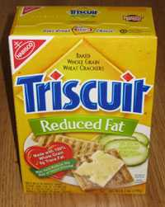
Joey: No! No, fear of the number 13.
Chandler: Fear of Triscuts?
Ross: It’s possible, they have really sharp edges.
sharp edge n.锋利的边缘
Joey: All right Chandler, you’re up.
Ross: Wait a minute, I-I believe I’m entitled to use my Angel Pass for a free turn?
be entitled to v.有资格[eg:Women are entitled to maternity leave]
Joey: Yes, yes. But you can only use it once, so choose wisely.
Ross: This is tricky. I mean, I am in the lead, but I would love another shot at the Golden Monkey.
tricky adj.难处理的/shot n.尝试 猜测(+at)[eg: He made a good shot at the exam]
Chandler: This game makes no sense!
make no sense <口>瞎胡闹
Ross: Y’know what? You’re just upset because you’re losing.
Chandler: Oh come on Ross, I think we’re all losers here.
Ross: I would like to hang on to my Angel Pass please.
hang on to v.To hold firmly;keep fast[eg: Hang on to your money]
Joey: All right. Chandler, you can either spin the wheel or pick a Google card.
Chandler: Let me think. Let me think—Oh! I don’t care.
Joey: You-you must choose Mr. Bing.
Chandler: Either, it makes no difference.
either prop.随便选一个/make no difference v.没有影响 都一样
Joey: Choose, you jackass!
Chandler: I’ll take a card.
Joey: Okay, you picked the Gimmie card! You get all of Ross’s points!
Ross: What?!
Chandler: This game is kinda fun.
Ross: (To Chandler) You don’t think it’s a little crazy that you get all my points just‘cause you…
Chandler: I don’t think the contestants are supposed to speak to each other.
[Scene: Monica and Chandler's, the baby shower is continuing as Rachel walks over to Monica and Phoebe.]
Phoebe: Now, do you wanna start opening presents because it seems like people are getting itchy to leave. And when I say people, I mean me.
itchy adj.渴望的
Rachel: Why did you invite my mother?!
Monica: What?
Rachel: She wants to move in with me and Ross to help take care of the baby.
Phoebe: For how long?
Rachel: Eight weeks. I mean I love my mother, but my God, a long lunch with her is taxing.
taxing adj.累赘的 艰难的
Monica: I personally would be honored if she wanted to live with me.
personally adv.作为个人[eg: I dislike him personally, but I admire his art]
Phoebe: She can’t hear you.
Rachel: What? You guys, come on! What am I gonna do?
Phoebe: Well, if you don’t want your mother to move in with you, just tell her.
Rachel: You’re right. You’re right. I mean I’m about to have a baby, I can tell my mother that I don’t want her to just be sleeping on my couch! Oh my God! She’s gonna want to sleep in my bed with me. This cannot happen!
Monica: That’s right. That is right, you go over there and tell her you do not want her to live with you. Do not take no for an answer!
Rachel: Okay. (She goes over to tell her mother.)
Monica: (To Phoebe) This is great! Now she’s gonna be mad at Rachel! Y’know what? And I’m just gonna swoop in there and be like the daughter she never had.
Phoebe: Oh, honey, you have to let it go.
Monica: Okay. Who doesn't accept an apology? I mean, it's just so simple.-I'm sorry, Sandra.-That's okay, Monica.I forgive you. And by the way, you're very pretty.
Phoebe: I have new respect for Chandler. All right everybody! It’s time to open the presents!
Monica: Yes! Yes! And I think that the first gift that Rachel opens should be from the grandmother of the baby, because you’re the most important person in this room. And in the world!
Mrs. Green: Well uh, I don’t have a gift because I wasn’t invited until the last minute, but thank you so much,just for bringing that to everyone’s attention.
Phoebe: How about you less important people, let’s open your presents!
(Mrs. Green goes into the kitchen and Rachel follows her.)
Rachel: Mom that’s okay that you didn’t get me a gift!
Mrs. Green: Well, I kinda did. Me. Eight weeks of me.
Rachel: Oh yeah. Okay, see mom, the truth is I can do this on my own.
on one’s own adv.独自地
Mrs. Green: Sweetheart I know you’re gonna be a terrific mom, I just think you need a little help, especially at the beginning.
Rachel: But mom, I really know what I’m doing. I can handle this.
Mrs. Green: Really? Remember Twinkles?
Rachel: He was a hamster! I am not going to vacuum up my baby!
hamster <动>仓鼠/vacuum vt. <口>用真空吸尘器清扫[eg:I vacuumed my room yesterday]
Phoebe: Okay, come on Rach it’s present time! Y’know you’re the glue holding this whole party together. It’s kinda falling apart here.
hold together v.使结合/fall apart v.支离破碎
Mrs. Green: Oh look.
Rachel: Wow!
Phoebe: Okay, this is from your friends at work.
Rachel: Oh my gosh! Oh wow! Oh, I know what this is! (She’s holding an item with a large suction cup connected to a yellow plastic box, with a long narrow tube and bottle connected the yellow part.) Wait a minute. That can’t be right. Is that a beer bong for a baby?
suction cup n.吸盘
beerbong
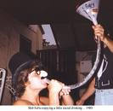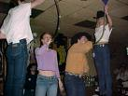
Mrs. Green: Darling, that’s a breast pump!
breast pump
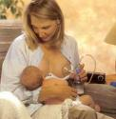
Rachel: Did I say I was done guessing? Okay, thank you for that. Oh wow! What’s this?
Woman: It’s a diaper genie.
genie n.神怪 神魔
diaper genie n.婴儿纸尿裤桶
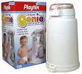
Rachel: Oh, it dispenses clean diapers!
dispense vt.分配 分发 施给[eg:The government dispensed emergency food to the flood victims]
Woman: No! It’s where you put the dirty ones!
Rachel: Well that’s gross, why don’t you just take it outside and throw it in a dumpster?
Mrs. Green: Oh you’re gonna do that ten times a day?
Rachel: What?! It goes ten times a day! What are we feeding this baby?! Indian food?!
Indian food
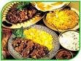
Mrs. Green: No dear, that’s what babies do.
Monica: Rachel, listen to your mother. She is very smart.
Mrs. Green: Plus, what are you planning on doing with the baby while you’re trotting out to the garbage ten times a day?
trot vt.(人)慢跑 急行[eg: The small boy trotted along after his brother]
Rachel: I don’t know, I’d leave it on the changing table? (Everyone gasps.) What?! What’d I do? What’d I do?!
changing table
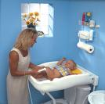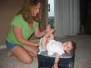
Mrs. Green: You can’t leave a baby alone!
Rachel: Oh come—(Stutters)—Of course I know that. I mean of course you never leave a baby alone! I mean who would—she wouldn’t be safe as she would be with me, the baby dummy. Oh God, okay. Y’know what? Opening the presents right now is a little overwhelming right now. So I think umm, I’m just gonna maybe open them a little bit later, but thank you all for coming. And for these beautiful gifts, and this basket is beautiful.
stutter v.口吃着说/dummy <口>笨人 傻瓜[eg: He was a dummy to agree]
Woman: It’s actually a bassinet.
bassinet n.摇篮
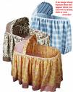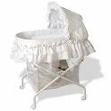
Rachel: Okay mommy, don’t ever leave me. (Hugs her.)
Commercial Break
[Scene: Joey's Apartment, the guys are still playing the game only everyone is really into it.]
Joey: (To Chandler) In what John Huston film would you hear this line, "Badges? We don’t need no stinkin’badges!"
badge n.徽章/John Huston，Treasure of the Sierra Madre:乔伊出的题中，有一道问到了关于约翰·侯斯顿(John Huston)制导的电影《碧血黄沙(Treasure of the Sierra Madre)》。约翰·侯斯顿是好莱坞五十年代左右最著名的大导演，他曾因《碧血黄沙》获得奥斯卡最佳导演奖。《碧血黄沙》描绘了发生在墨西哥的一个关于贪婪、谋杀和恐惧的电影/John Marcellus Huston (August 5, 1906 – August 28, 1987) was screenwriter, actor and Academy Award-winning director (Father of actress Angelica Huston and director Danny Huston)
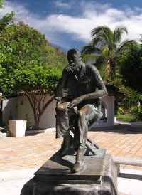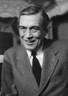
Chandler: Treasure of the Sierra Madre!
Sierra Madre n.马德雷山脉(环绕墨西哥高原的三条山脉的总称)/The Treasure of the Sierra Madre is a black-and-white 1948 John Huston film in which two American down-and-outers (Humphrey Bogart and Tim Holt) in 1920s Mexico hook up with an old-timer (Walter Huston, the director's father) to prospect for(v.勘探) gold. The old-timer(n.老前辈 老法师) accurately predicts trouble but is willing to go anyway. The Treasure of the Sierra Madre was one of the first Hollywood films to be shot almost entirely on location outside the U.S. (in Tampico, Mexico), although the night scenes were filmed back in the studio.
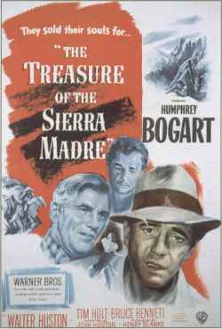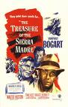
Joey: Correct! There’s a possible backwards bonus!
Chandler: Madre Sierra the of Treasure!
Joey: Yes!
Ross: What? There's extra points for that? Fair not that's!
Chandler: I’d like to go up the ladder of chance to the golden mud hut please.
Joey: Wise choice, how many rungs?
rung n.(楼梯的)横档
Chandler: Six!
Joey: (makes a sound like a monkey) That noise can only mean one thing.
Chandler: (disappointed and simultaneously as Ross) Hungry monkey.
Ross: (excited and simultaneously as Chandler) Hungry monkey! (To Chandler) Haaa! (To Joey) I’d like a Wicked Wango card!
Joey: Okay, it’s an audio question, name this television theme song. (Starts humming the theme to I Dream of Jeannie.)
audio adj.音频的/television theme song n.电视主题曲/I Dream of Jeannie was a popular American sitcom with a fantasy premise(n.前提). Produced by Screen Gems, it aired from 1965 to 1970 on NBC. The show starred Barbara Eden as Jeannie and Larry Hagman as Captain (later Major) Anthony Nelson.
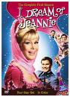
Ross: (thinking) Oh. (Pause) Oh! Oh my God! Okay, I know this, give me-give me a second!
Chandler: Tell it to the Time Turtle!
Ross: Shut up! I Dream of Jeannie!
Joey: Yes! Yes, you’re back in the lead!
Ross: I’d like to spin the wheel!
(Joey makes a sound like a game show wheel spinning with the pointer bouncing off of the bars on the wheel as it slows and comes to a stop.)
pointer n.指针
Chandler: (annoyed) Oh come on!!
Joey: All right! All right! Uh, umm, Super-Speedy Speed round!
speedy adj.快速的
Ross: Is there a hopping bonus?
Joey: Of course!
(Ross gets up and starts to hop on one leg.)
Joey: Who invented bifocals?
bifocal n. 双重焦点透镜 双光眼镜

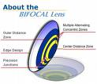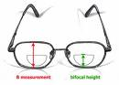
Ross: Ben Franklin.
Ben Franklin,Bifocals:乔伊问是谁发明了两用眼镜(bifocals)，也就是既有老花镜、也有近视镜的眼镜。罗斯答：本·富兰克林(Ben Franklin)，这个答案是正确的/Benjamin Franklin (January 17 1706 O.S. January 6] – April 17 1790) was one of the best known Founding Fathers of the United States. He was a leading author, politician, printer, scientist, philosopher, publisher, inventor, civic activist, and diplomat. As a scientist he was a major figure in the history of physics for his discoveries and theories regarding electricity. As a political writer and activist he, more than anyone, invented the idea of an American nation, and as a diplomat during the American Revolution, he secured the French alliance that made independence possible.
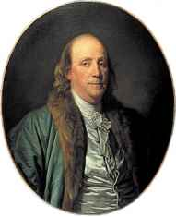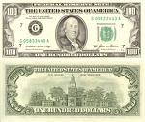
Joey: Correct! Which monarch has ruled Great Britain the longest?
monarch n.君主/Great Britain n.英国
Ross: Queen Victoria.
Queen Victoria:乔伊接着问统治英国时间最长的君主，罗斯的答案是维多利亚女王。这也是对的，维多利亚女王在位六十三年，是英国历史上在位时间最长的君主/Victoria (Alexandrina Victoria; 24 May 1819 – 22 January 1901) was the Queen of the United Kingdom of Great Britain and Ireland from 20 June 1837, and the first Empress(n.皇后) of India from 1 January 1877, until her death in 1901. Her reign lasted more than sixty-three years, longer than that of any other British monarch.The Victorian era was at the height of(adv.在…的高潮之中) the Industrial Revolution(n.工业革命), a period of significant social, economic, and technological change in the United Kingdom. Victoria's reign was marked by a great expansion of the British Empire and during the period it reached its zenith(n.顶峰), becoming the formidable(adj.令人敬畏的) global power of the time.Victoria, who was almost entirely of German descent (except from her ancestor Sophia of Hanover, who was a female-line granddaughter of James I), was the last monarch of the House of Hanover; her son King Edward VII belonged to the House of Saxe-Coburg and Gotha.
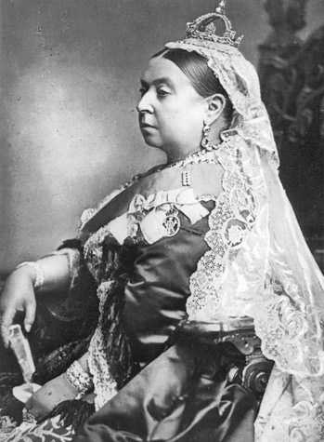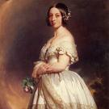
Joey: Correct again! But, you forgot to switch legs between questions, so no hopping bonus!
Ross: Noooo!!! Every time!!!
Joey: Now, over to Chandler.
Chandler: I’d like a Google Card.
Joey: Are you sure?
Chandler: Yes! (Pause) No! (Pause) Google!
Joey: Oh my God! Congratulations Ross, because Chandler, you’ve been Bamboozled!
Chandler: Nooo!!
Ross: Yeah!!
Chandler: This is the best game ever!!!
[Scene: Monica and Chandler's, the baby shower has ended and everyone except for Mrs. Green have left who is talking to Rachel while Monica and Phoebe are cleaning up.]
Rachel: So umm, you’re gonna stay with me as long as I need you?
Mrs. Green: Of course I am!
Rachel: Oh mom, I swear I’m not an idiot. I’ve read all kinds of books on pregnancy and giving birth, but I-I just didn’t think to read the part about what to do when the baby comes. And-and then guess what? The baby’s coming and I don’t know what to do. Oh, can I throw up in my diaper genie?
Mrs. Green: No. Sweetie, you’re gonna be fine. (Starts to get up.)
Rachel: Wait-wait where are you going? Where are you going?
Mrs. Green: I’m going to the bathroom.
Rachel: Okay.
Mrs. Green: Now don’t worry! Everything’s gonna be okay. (Hugs Rachel while she is standing and Rachel is sitting, seeing this Monica decides to join in on the hugging by hugging Mrs. Green from behind her back.)
Monica: It is going to be okay! (Mrs. Green glances over her shoulder and glares at Monica while she heads for the bathroom.) It was worth a shot.
Ross: (entering, out of breath) Hey!
Phoebe: Hey! Why are you all red and sweaty?
Ross: I just Bamboozled Chandler! (Flexes in victory while everyone stares at him.) Which is not uh sexual thing. That was a quick shower.
flex in victory

Phoebe: Not if you were here.
Ross: Wow! It looks like we got a lot of good stuff.
Rachel: Oh we did, but my mom got us the greatest gift of all.
Ross: (excited) A Play-Dough Barber Shop?
barber shop n.理发店/Play-Doh is a commercial modeling compound similar in texture to bread dough that has been sold as a children's toy around the world for a half century. Its exact makeup is a secret, but it is primarily a mixture of wheat flour(n.小麦粉), water, deodorized kerosene(n. 脱臭煤油) or another petroleum distillate(n.石油馏出物) (which provides the smooth texture), salt, a drying agent such as borax (which deters mold), an alum-based hardening agent, and colourings and perfume.培乐多
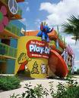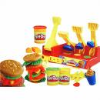
Rachel: No. She’s going to live with us for eight weeks.
Ross: Uh, what?
Rachel: Yes! She’s gonna help us take care of the baby! Woo-hoo. (Sees that Ross isn’t happy.)
Ross: What—You’re not serious. I mean she’s a very nice woman, but there is no way we can take eight weeks of her. She’ll drive us totally crazy.
there is no way <口>不可能
Mrs. Green: (entering from bathroom) Hi Ross!
Ross: Hi roomie! (Hugs her and looks at Rachel.)
[Scene: Joey’s Audition, Joey is being shown in.]
Man: Hey Joey, hi! I’m Ray; I’m the producer of the show.
Joey: (announcer voice) It’s a pleasure to meet you Ray.
Ray: And this is Duncan (points to the cameraman) and Erin, they’re gonna help us out with the audition. So uh, let’s get the camera rolling.
cameraman n.摄像师
Joey: (announcer voice) Rightie-O Ray!
Ray: Whenever you’re ready.
Joey: (to the camera) Hello, I’m Joey Tribbiani! Let’s play Bamboozled! Erin, you get the first question! In hockey, who is known as The Great One?
The Great One 最伟大的选手
Erin: Wayne Gretzky.
Wayne Gretzky:乔伊去电视台录制节目，第一个问题是冰球界谁有“最伟大的一个”这个称号，答案是纽约轻骑兵的韦恩·格雷茨基,他曾经被评为世纪最佳冰球运动员

Joey: Correct! Now, would you like to pick a Wicked Wango card or spin the Wheel of Mayhem?
Ray: Uh Joey, didn’t your agents give you the revised rules? We’ve eliminated all of that. No wheel, no cards.
Joey: What—Why?!
Ray: Uh well, the game was too complicated and research showed people didn’t follow it.
Joey: Well what’s complicated? You spin the Wheel of Mayhem to go up the Ladder of Chance. You go past the Mud Hut through the Rainbow Ring to get to the Golden Monkey; you yank his tail and boom! You’re in Paradise Pond!
yank v.猛拉
Ray: Yeah all that’s gone. It’s basically just a simple question and answer game now.
Joey: Well what’s fun about that? You expect me to be the host of a boring game that’s just people standing around answering questions?
Ray: Well, there’ll be women in bikinis holding up the scores.
Joey: (announcer voice to the camera) Let’s play Bamboozled!
[Scene: Monica and Chandler's, Mrs. Green is telling Ross what needs to be done to baby proof his apartment.]
Mrs. Green: So I thought we'd put the changing station in the living room. I thought I'd bring in my decorator because I feel like I'm at my best when surrounded by jewel tones.
changing station/decorator n.室内装潢师/at one’s best adv.处在最佳状态/tone n.风气 气氛[eg: The tone of the school is excellent]
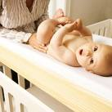
Ross: Sure, who doesn't?
Mrs. Green: Oh，and all those dinosaur knickknacks you have Ross, I thought they might be more at home in the garage.
knickknack n.小玩意儿 小摆设
Ross: Well we…we don’t have a garage.
Mrs. Green: Did I say garage? I meant garbage.
garbage n.垃圾
Ross: Y’know what? Maybe, Mrs. Green, it’s not absolutely vital that you live with us.
vital adj.所必需的
Mrs. Green: Well Rachel needs help with the baby.
Rachel: I do. I really do. I don’t know anything.
Ross: I’m-I’m sure that’s not true.
Rachel: Oh no? Pheebs? Monica? Do I know anything about babies?
Phoebe: No, not a thing.
Monica: It’s frightening.
Ross: Well uh, y’know what? Even if she doesn’t know anything, I do! And I'll be there to show her.
Mrs. Green: That's exactly what Rachel's father told me.Know what he said at the first 3 a.m. feeding? I'm tired. You take care of it,which I later said to him when he wanted to have sex.
Ross: Well, I'm not Rachel's dad. And no offense, but he's an ass.
ass <俚>笨蛋 傻子[eg: Don't be such an ass, stop clowning around]
Mrs. Green: I do like you, Ross.
Ross: Look，I have a son. And his mother and I didn’t live together, and whenever he was with me I took care of him all the time, by myself.
Mrs. Green: That’s true. You do have another child.
Ross: Yeah.
Mrs. Green: With another woman. Have you no control Ross?
Ross: That’s a different issue. Uh, the point is, when the baby comes I will be there to…to feed her and bathe her and change her. And more than that I want to do all those things.
bathe v.给...洗澡[eg: Will you help me bathe the baby?]
Mrs. Green: Well then you really don’t need me to live with you.
well then adv.那么
Ross: Yes! Yes, you’re gonna be so missed.
Mrs. Green: You’re gonna be a great father.
Ross: Well you’re gonna be a wonderful grandma. (They hug.)
Rachel: Hello?! I still don’t know what the hell I’m doing!
Ross: Oh, come on, every first time mother feels that way. You’ll—you’re gonna pick it up. (Rachel doesn’t believe that.) Hey! You will! Uh look, y’know when you first came to the city? You were this spoiled helpless little girl who-who still used daddy’s credit card. Do you remember?
pick it up v.慢慢学
Rachel: I hope you’re going somewhere with this.
Ross: Look at you! What—You’re-you’re this big executive! You are much more capable than you give yourself credit for. I-I have no doubt you’re gonna be an incredible mother.
executive n.主管 经理主管人员/credit n.(经济上的)信誉[eg: Our international credit is excellent]
Rachel: Really?
Ross: I’m telling you.
Rachel: Thank you. (Hugs him.)
Mrs. Green: All right you two, I’m gonna get going.
Ross: Oh. (Rachel and he start to stand up.)
Mrs. Green: Oh no-no-no-no sweetheart, you stay put. I’ll let myself out. It’s like I’m not here, which I almost wasn’t.
stay put<美口>原地不动 不用送了
Monica: (laughs) You’re still so funny. You’re so funny. (To Phoebe) What do I do?
Phoebe: Nothing! You have apologized to her like a million times and she’s been nothing but terrible to you. And don’t forget you just threw her daughter a lovely, albeit slightly boring, shower, and she hasn’t even thanked you for it.
albeit <书>尽管 虽然[eg:The cure for the disease is effective, albeit expensive]
Monica: Y’know what? You’re-you’re right.
Phoebe: Yeah I mean if you want to say anything to her, I’d tell her off.
tell off<俚>To rebuke severely;reprimand 斥责
Monica: Really?
Phoebe: Uh-huh!
Monica: Okay! I will! Mrs. Green? Mrs. Green! (She ignores Monica who follows her out into the hall with Phoebe in tow.) It is rude to leave a party without saying good-bye to the host! Yeah, and-and also when someone apologizes to you, the decent thing to do is to accept it!‘cause what I did to you, it wasn’t on purpose! But what you’re doing to me now is just plain spiteful!
plain ad.<口>完全地 彻底地[eg:She's just plain silly]/spiteful adj.怀恨的 恶毒的[eg:It was very spiteful of her to do that]
Mrs. Green: Spiteful?!
Monica: That’s right! Maybe it’s time you took a good hard look at a mirror young lady…old lady…lady!
Phoebe: (To Monica) Wrap it up, wrap it up, wrap it up…
wrap it up<口>别说了 收尾
Monica: So whenever you’re ready to apologize to me, I will forgive you. Good day! (Monica and Phoebe reenter the apartment and Monica closes the door on a stunned Mrs. Green.) I can’t feel my legs!
good day n.日安(白天见面或分手时之招呼)
Phoebe: You were fantastic! I’m so proud of you!
Monica: Yeah? I’m proud of me too.
Phoebe: You should be!
Monica: Yeah could-could-could you get me something to drink?
Phoebe: You got it!
you got it<口>(别人要求你拿东西时回答)没问题
Monica: Okay. (When Phoebe turns around Monica runs out into the hall after Mrs. Green.) Mrs. Green! Okay I’m really sorry!! I’m apologizing for the—(She trips and falls down the stairs.) (Pause) Okay, I bit my tongue, but I’m still really sorry!
trip v.跌倒
Closing Credits
[Scene: Ross and Rachel's, Ross is helping Rachel study for when the baby comes.]
Rachel: (closing a book) Okay! I’m ready.
Ross: You sure?
Rachel: Yes, I’ve done my studying and I really know my stuff.
Ross: All right then. (Gets up, in an announcer’s voice) Rachel Green! Let’s play Bamboozled! (Reading from a note card.) How do you test the temperature of the baby’s bath water?
bath water n.洗澡水
Rachel: Uh, put your elbow in it.
Ross: Excellent! How do you put a baby down for a nap?
Rachel: Full, dry, on its back, and no loose covers.
full:喂饱/dry:换干尿布/on its back面朝天睡/no loose covers把被子盖紧
Ross: That’s correct! There's a hopping bonus here, but I don't suggest you take it.Okay.This is an audio question, what do you do when the baby makes this sound? (Makes a sound like someone is choking a cat.)
Rachel: Check if it’s wet, check if it’s hungry, burp it!
wet adj.尿布湿的/burp vi.打嗝
Ross: Excellent! Excellent, now-now do you want another question or a Wicked Wango card?
Rachel: A card! A card! I pick a card!
Ross: Oh, I’m sorry you’ve been Bamboozled! You’re gonna be a terrible mother! (Rachel stares at him agape.) I’ve lost sight of why we’re doing this! (Rachel gets up and walks away.) PIease don't walk away.I've gone too far.
agape adv.目瞪口呆地/lose sight of v.忽略 忘记/go too far v.做的过火
End

